Assignment No. 1
Q1: Solution:
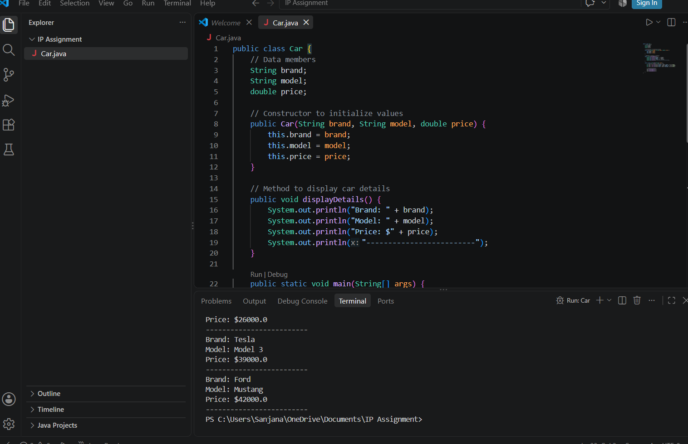
Code:
public class Car {
// Data members
String brand;
String model;
double price;

// Constructor to initialize values
public Car(String brand, String model, double price) {
this.brand = brand;
this.model = model;
this.price = price;
}

// Method to display car details
public void displayDetails() {
System.out.println("Brand: " + brand);
System.out.println("Model: " + model);
System.out.println("Price: $" + price);
System.out.println("-------------------------");
}

public static void main(String[] args) {
// Creating 3 objects of the Car class
Car car1 = new Car("Toyota", "Camry", 26000);
Car car2 = new Car("Tesla", "Model 3", 39000);
Car car3 = new Car("Ford", "Mustang", 42000);

// Displaying details
car1.displayDetails();
car2.displayDetails();
car3.displayDetails();
}
}
Output:
Price: $26000.0
-------------------------
Brand: Tesla
Model: Model 3
Price: $39000.0
-------------------------
Brand: Ford
Model: Mustang
Price: $42000.0

Q2: Solution:
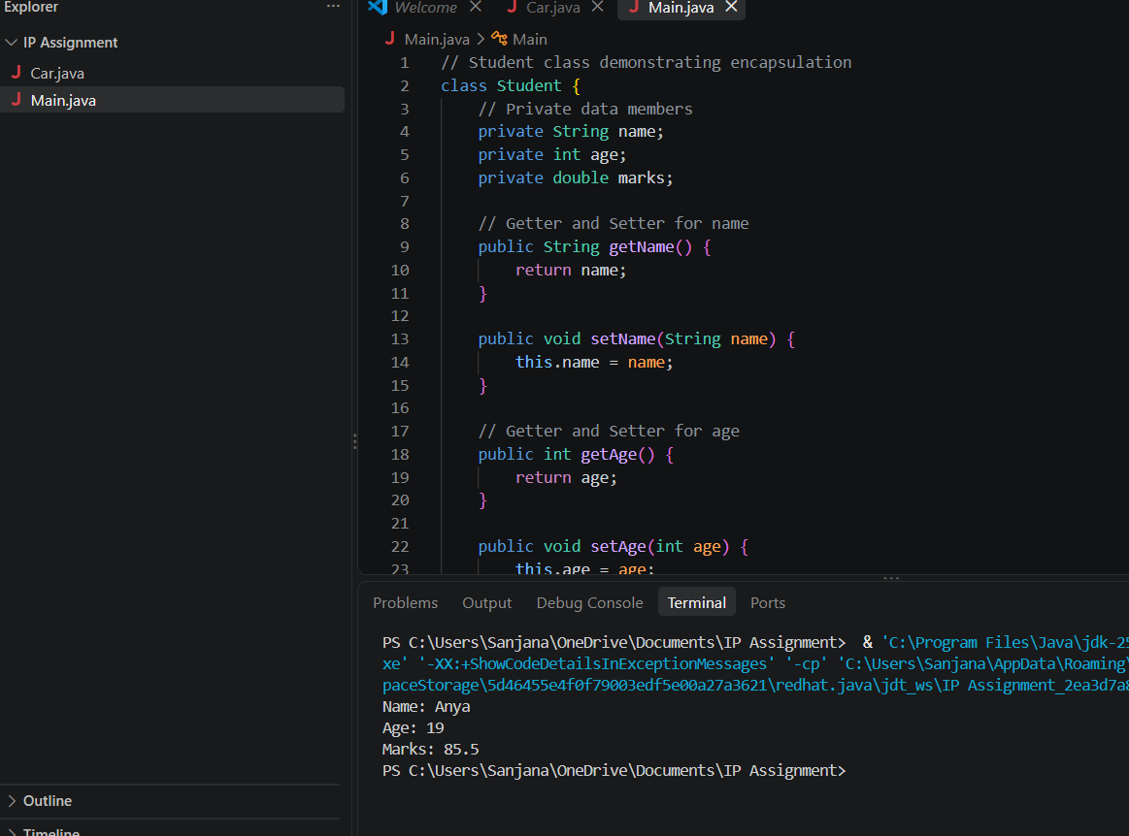

Code:
// Student class demonstrating encapsulation
class Student {
// Private data members
private String name;
private int age;
private double marks;

// Getter and Setter for name
public String getName() {
return name;
}

public void setName(String name) {
this.name = name;
}

// Getter and Setter for age
public int getAge() {
return age;
}

public void setAge(int age) {
this.age = age;
}

// Getter and Setter for marks
public double getMarks() {
return marks;
}

public void setMarks(double marks) {
this.marks = marks;
}
}

// Main execution class
public class Main {
public static void main(String[] args) {
// Create Student object
Student s = new Student();

// Set values using setters
s.setName("Anya");
s.setAge(19);
s.setMarks(85.5);

// Display values using getters
System.out.println("Name: " + s.getName());
System.out.println("Age: " + s.getAge());
System.out.println("Marks: " + s.getMarks());
}
}
Output:
Name: Anya
Age: 19
Marks: 85.5

